Dismissal in 30% of the organisations in the Belgian event sector
KdG centre of expertise Public Impact monitors the impact of the corona crisis

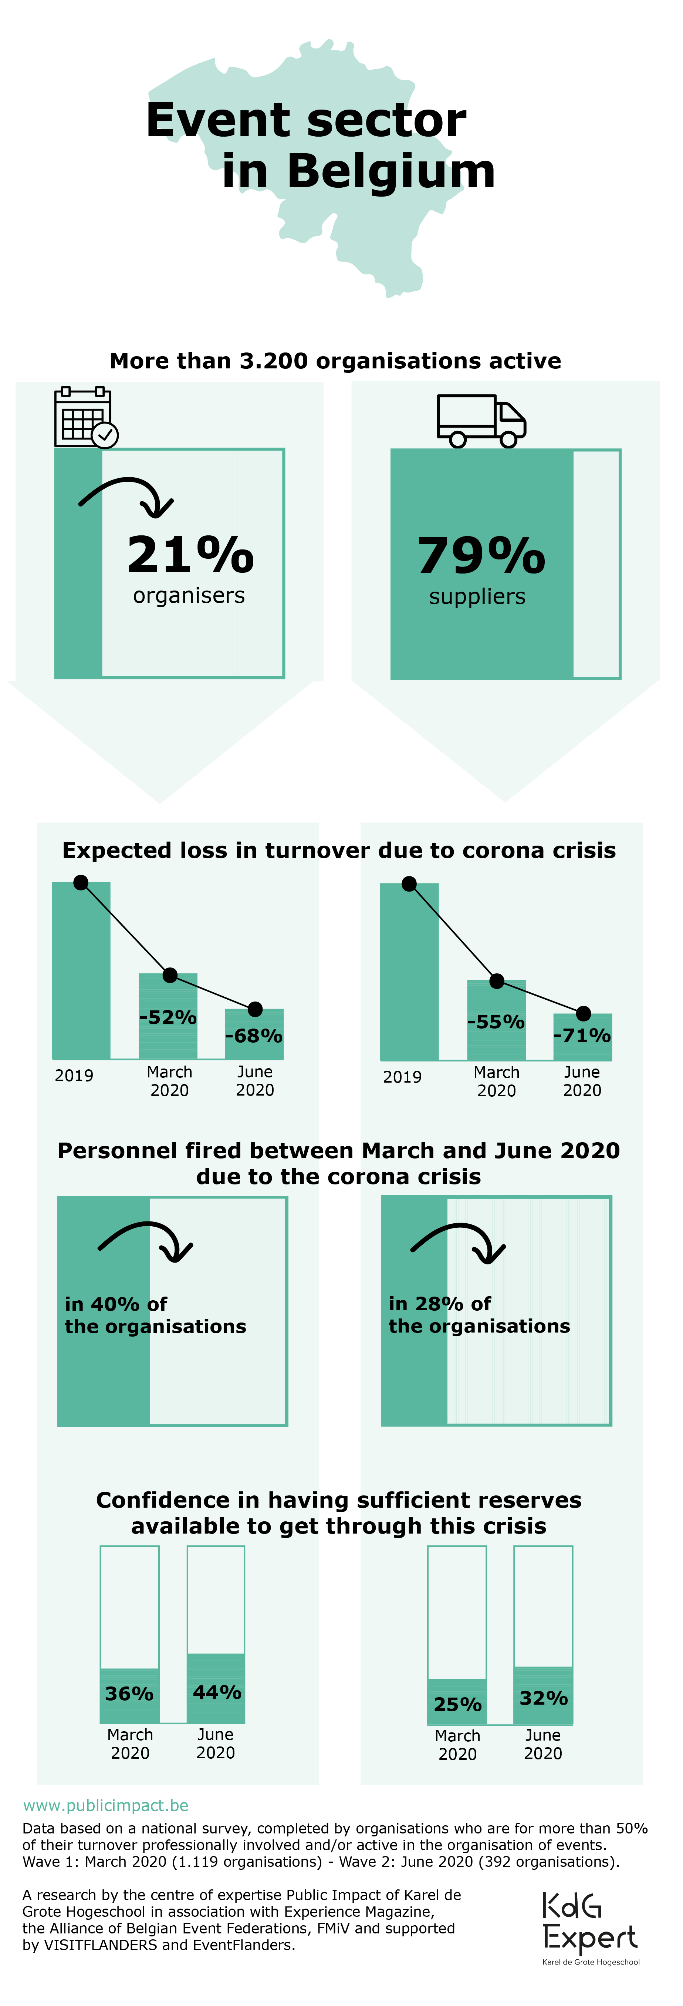
Over the past three months, as many as three out of ten organisations active in the event sector had to let staff go. Six out of ten organisations expect that they will have to lay people off in the next three months as well. This is evident from the second national sector survey conducted by the centre of expertise Public Impact of KdG University of Applied Sciences and Arts since the outbreak of the corona crisis. The survey is an initiative of Experience Magazine, the Alliance of Belgian Event Federations, FMiV, VISITFLANDERS and EventFlanders.

The layoffs are a result of the many cancelled and postponed events. The expected loss of turnover increases every month. Researcher Joris Verhulst explains: "For a third of the organisations, all planned events have already been cancelled until the end of the year. Six out of ten organisations think that more than half of all events will be cancelled or postponed in 2020. For most organisations 2020 turns out to be a lost year.”

Expected loss in 2020 even higher than previously thought

Organisers of events in Belgium expect a loss in turnover of 68% in 2020 compared to 2019. This is an even greater loss than they expected at the end of March. At that time, this loss was estimated at 52%. The loss in turnover event suppliers expect (such as catering, decoration, audiovisual support, etc.) has increased significantly in June. Whereas in March it was estimated at 55% for this year, the damage is already estimated at 71%. Event organisers estimate the loss at 1.7 billion euros. Suppliers expect to lose more than 4.7 billion euros.

"The figures show a severely affected sector due to the corona crisis," says the head of the centre of expertise Public Impact Christine Merckx. "Yet we also see signs of hope. More organisers and suppliers than in March trust that their organisation has sufficient reserves to survive the crisis. The sector is making good use of government support measures and they appear to be helping. The perspective of a relaunch of the sector can also give rise to this mild optimism.”

The survey

At the beginning of June, more than 12% of all event professionals in Belgium completed the survey. These organisations are for more than 50% of their turnover professionally involved or active in the organisation of events, conferences, fairs, festivals, incentives and/or meetings.

This survey is part of a series of surveys. The event sector was surveyed for the first time in March. This survey in June is the second. In September and December of this year, the sector will be surveyed again. The aim is to monitor the impact of the corona crisis on the event sector, now and in the future.
For interviews and more information, contact:
Julie De Smedt, press & communication of the centre of expertise Public Impact
julie.desmedt@kdg.be - 0494 89 79 83
Christine Merckx, head of the centre of expertise Public Impact
christine.merckx@kdg.be - 0473 69 21 84

Centre of expertise Public Impact
Public Impact is a centre of expertise of KdG University of Applied Sciences and Arts. It conducts applied scientific research, the aim of which is to ‘improve’ events and cities. Having better events and cities will generate more public impact which, in turn, will bring about more effective use of resources, people and materials.

The researchers develop knowledge and expertise which they translate into tools and guidelines tailored to the sector. Together with a network of coaches and consultants, the centre of expertise also guides and trains (future) event professionals, both for the public sector and the (non-)profit sector.

