The Belgian event sector expected to further slide downhill, but continues to innovate creatively
KdG centre of expertise Public Impact monitors the impact of the corona crisis

A third survey wave of the Belgian event sector once again reveals heavy figures. Although the sector is proceeding cautiously, redundancies have been unavoidable for many companies. Turnover is also continuing to shrink, and confidence in the future is declining further. At the same time, however, the sector is showing its most creative side. Companies are reforming, personnel are being lent out to other sectors and expertise is being deployed in other areas. In terms of content, too, new types of events are in full swing, and many are taking steps towards online, digital and hybrid events.

This third survey of the Belgian event sector was conducted by the centre of expertise Public Impact of KdG University of Applied Sciences and Arts and is an initiative of VISITFLANDERS, EventFlanders, Experience Magazine, FMiV and the Alliance of Belgian Event Federations.
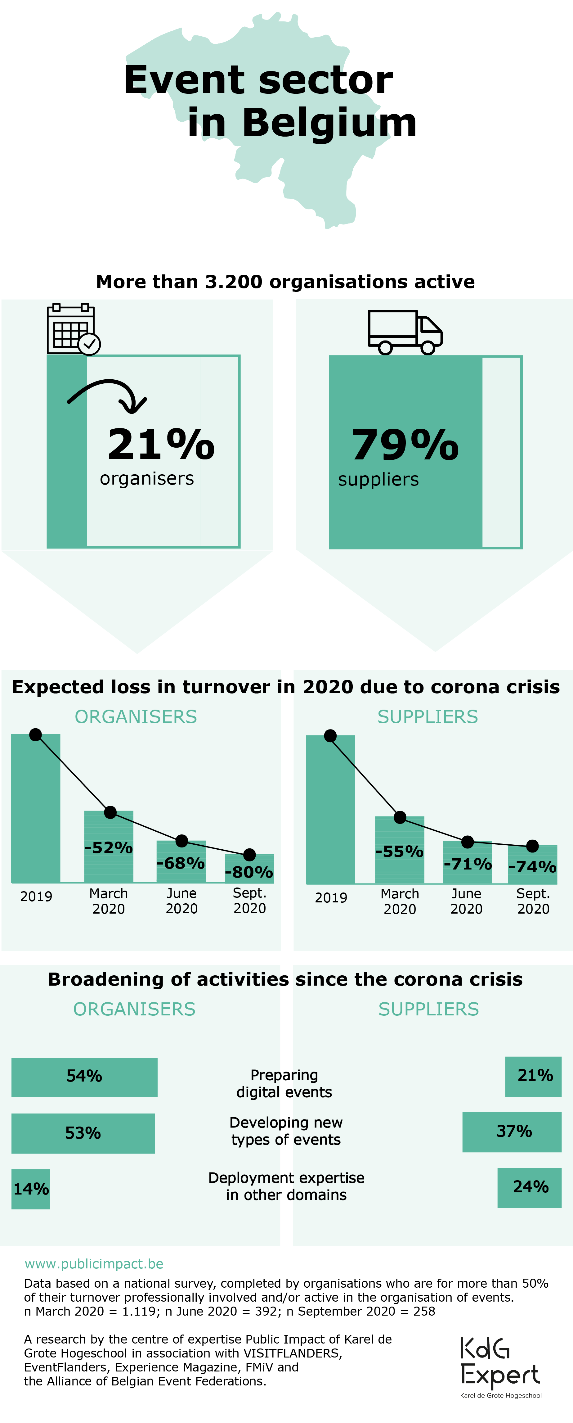
A second wave of redundancies and an uncertain 2021
One in five event companies has had to let people go in the last three months. The redundancies are a result of many cancelled and postponed events and come on top of a first wave of redundancies before the summer, where one in three companies already had to make staff redundant. According to researcher Joris Verhulst, the sector looks with uncertainty towards the future: "Half of the event organisations expect to lay off staff (still) before the end of the year. In addition, a quarter of the organisers and a third of the suppliers also had to see people leave for sectors with greater job security. Even in the longer term, the sector does not have full confidence. As many as eight out of ten organisations think that the turnover in 2021 will be lower than in 2019. A revival of the sector and of employment in the sector therefore does not seem to be in sight immediately.

Turnover continues to fall, support needed more than ever
Belgian event organisers predict a loss of turnover of no less than 80 percent in 2020 compared to 2019. This is even more than they thought they would lose at the end of March (52%) and June (68%). The expected loss of turnover from event suppliers (such as catering, decoration, audiovisual support, etc.) also rose again in September, to 74 percent. Fortunately, the sector continues to make good use of public support measures. Nevertheless, more than two out of three organisations (70%) state that this support is insufficient for their organisation.

A creative sector committed to innovation
Despite the series of setbacks that the sector has had to endure over the last six months, it is not giving in. Many companies (1 in 5) are in the process of restructuring and are lending staff to companies in other sectors (16% from the organisers, 24% from the suppliers). Approximately the same number of companies are deploying their expertise in other areas of society. ‘And', says researcher Joris Verhulst, 'companies are also reforming creatively in terms of content: more than half of the organisers are currently setting up digital/online or 'hybrid' events (53%). An equally large group is developing new types of events (54%). Many suppliers are also doing so as well, with 21 and 34 percent respectively. It is clear that the sector shows its resilience even in its darkest days and continues to build creatively for the future'.

The survey
This survey is part of a series of surveys. The aim is to monitor the impact of the corona crisis on the event sector, now and in the future. The first two surveys took place in March and June. In September, 258 organisations took part in this third survey. This corresponds to 8% of all event professionals in Belgium. These are organisations that are professionally involved or active in the organisation of events, conferences, fairs, festivals, incentives and/or meetings for more than 50 percent of their turnover. In December of this year, the sector will be surveyed for the fourth time since the outbreak of the corona crisis.

For interviews and more information, contact:
Julie De Smedt, press & communication of the centre of expertise Public Impact
julie.desmedt@kdg.be - 0494 89 79 83
Joris Verhulst, senior researcher of the centre of expertise Public Impact
Joris.verhulst@kdg.be - 0486 47 53 86

Centre of expertise Public Impact
Public Impact is a centre of expertise of KdG University of Applied Sciences and Arts. It conducts applied scientific research, the aim of which is to ‘improve’ events and other urban activities. Having better events will generate more public impact which, in turn, will bring about more effective use of resources, people and materials.The researchers develop knowledge and expertise which they translate into tools and guidelines, tailored to the sector. Together with a network of consultants, the centre of expertise also guides and trains (future) event professionals, both for the public sector and the (non) profit sector.

EventFlanders
EventFlanders was set up in 2016: a specialised unit that takes Flemish events to a higher level and tracks down international events. EventFlanders works within VISIT FLANDERS and is supported by the Department of Foreign Affairs, the Department of Culture, Youth and Media and Sport Flanders.

