Corona measures at events: increasing support from visitors
KdG centre of expertise Public Impact monitors the impact of the corona crisis

Of all Belgians who visited events before the corona crisis, more than a third visited events again this summer. Event visitors consider the current safety measures to be essential. Even more than before the summer, visitors value the importance of social distancing and mouth masks at events. And good news for the event sector: two out of three visitors trust that organisers will make their events as corona proof as possible. This is evident from the second survey of 1,000 Belgians conducted by the centre of expertise Public Impact of KdG University of Applied Sciences and Arts in response to the corona crisis.
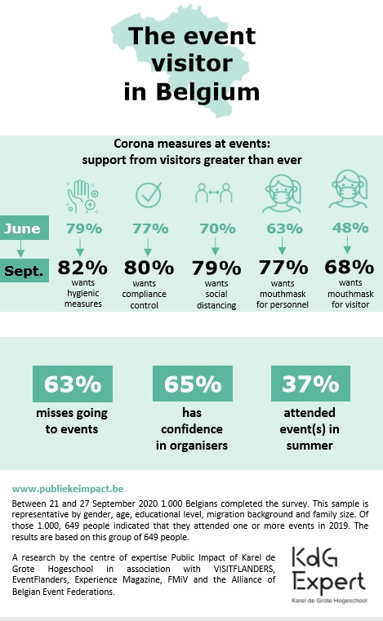
For more and more event visitors, mouth masks are an indispensable precondition for attending events. Almost 80 percent does not want to go to an event if the staff does not wear a mask. And almost 70 percent does not want to go if visitors do not wear mouth masks. "Social distancing at events is also important for visitors," says researcher Jolien Vangeel. "They value this even more than before the summer. Currently, almost 80 percent of the visitors, in all age groups, also those in their twenties and thirties, regard social distancing as a precondition for even wanting to attend events".

Strong desire for more events
As many as two-thirds of the visitors today miss going to events. The demand and especially the longing for more and safe events is large. Researcher Jolien Vangeel emphasises that organisers should therefore continue to plan and organise events in a safe way, because this is what the visitors really want. Research shows that more and more people really value the current corona measures.

Good use of COVID Event Risk Model
Until the end of June, the event sector was in lockdown. In order to unlock the sector, the centre of expertise developed in cooperation with VISITFLANDERS, EventFlanders and the Alliance of Belgian Event Federations the COVID Event Risk Model (CERM): an online tool mapping the COVID security risk of each type of event. The quarterly sector survey of September, also conducted by the centre of expertise, showed that 61 percent of the organisers and 33 percent of the suppliers use the CERM. "The CERM monitors and provides guidelines for organising COVID safe events," says the head of the centre of expertise Christine Merckx. "This offers certainty and perspective for the organisers of events. Event professionals dare to organise again. Almost half of these organisations work on events that are still planned for this year. Six out of ten organisations work on events taking place in 2021. They are even looking forward to 2022: one in five organisations is organising or supplying one or more events in that year.”

The surveys
Survey of event visitors
In both June and September, 1,000 Belgians were surveyed. The data are representative by gender, age, level of education, migration background and family size. On average seven out of ten Belgians indicated that they attended one or more events in 2019. The results are based on this group of event visitors.

Survey of event sector
The organisers and suppliers were surveyed in March, June and September. An average of 18 percent of all event professionals in Belgium completed the sector survey. These are organisations that are professionally involved or active in the organisation of events, conferences, fairs, festivals, incentives and/or meetings for more than 50 percent of their turnover.

Both surveys are part of a series of quarterly surveys, conducted by the centre of expertise since the outbreak of the corona crisis. The surveys are commissioned by VISITFLANDERS and EventFlanders and an initiative of the Alliance of Belgian Event Federations, FMiV and Experience Magazine. The aim is to monitor the impact of the corona crisis, both now and in the future, among both the event professionals and the event visitors.

For interviews and more information, contact:
Julie De Smedt, press & communication of the centre of expertise Public Impact
julie.desmedt@kdg.be - 0494 89 79 83
Jolien Vangeel, senior researcher of centre of expertise Public Impact
jolien.vangeel@kdg.be - 0474 23 36 05

Centre of expertise Public Impact
Public Impact is a centre of expertise of KdG University of Applied Sciences and Arts. It conducts applied scientific research, the aim of which is to ‘improve’ events and other urban activities. Having better events will generate more public impact which, in turn, will bring about more effective use of resources, people and materials.The researchers develop knowledge and expertise which they translate into tools and guidelines, tailored to the sector. Together with a network of consultants, the centre of expertise also guides and trains (future) event professionals, both for the public sector and the (non) profit sector.

EventFlanders
EventFlanders was set up in 2016: a specialised unit that takes Flemish events to a higher level and tracks down international events. EventFlanders works within VISITFLANDERS and is supported by the Department of Foreign Affairs, the Department of Culture, Youth and Media and Sport Flanders.

